 | JCNA Life Membership
JCNA is once again offering members the opportunity to become “Life Members”
Benefits
- Pay $500 One-Time fee and all JCNA dues are paid for life of member (Note: Club fees must still be paid)
- Prevents Member from having to pay any future JCNA Dues Increases
- Life Member Polo Shirt (One per Membership, Additional shirts at $28 each)
- Life Member Name Tag with clear lens • Additional Life Member’s Name Tag at $15.00 each
- Life Member Numbered Car Badge • Optional Life Member’s First Name on shirt
- Life Member Lapel Pin • Optional Life Member’s Club Initials on shirt
- Life Member Regalia - $100 value • Laminated Life Membership Card
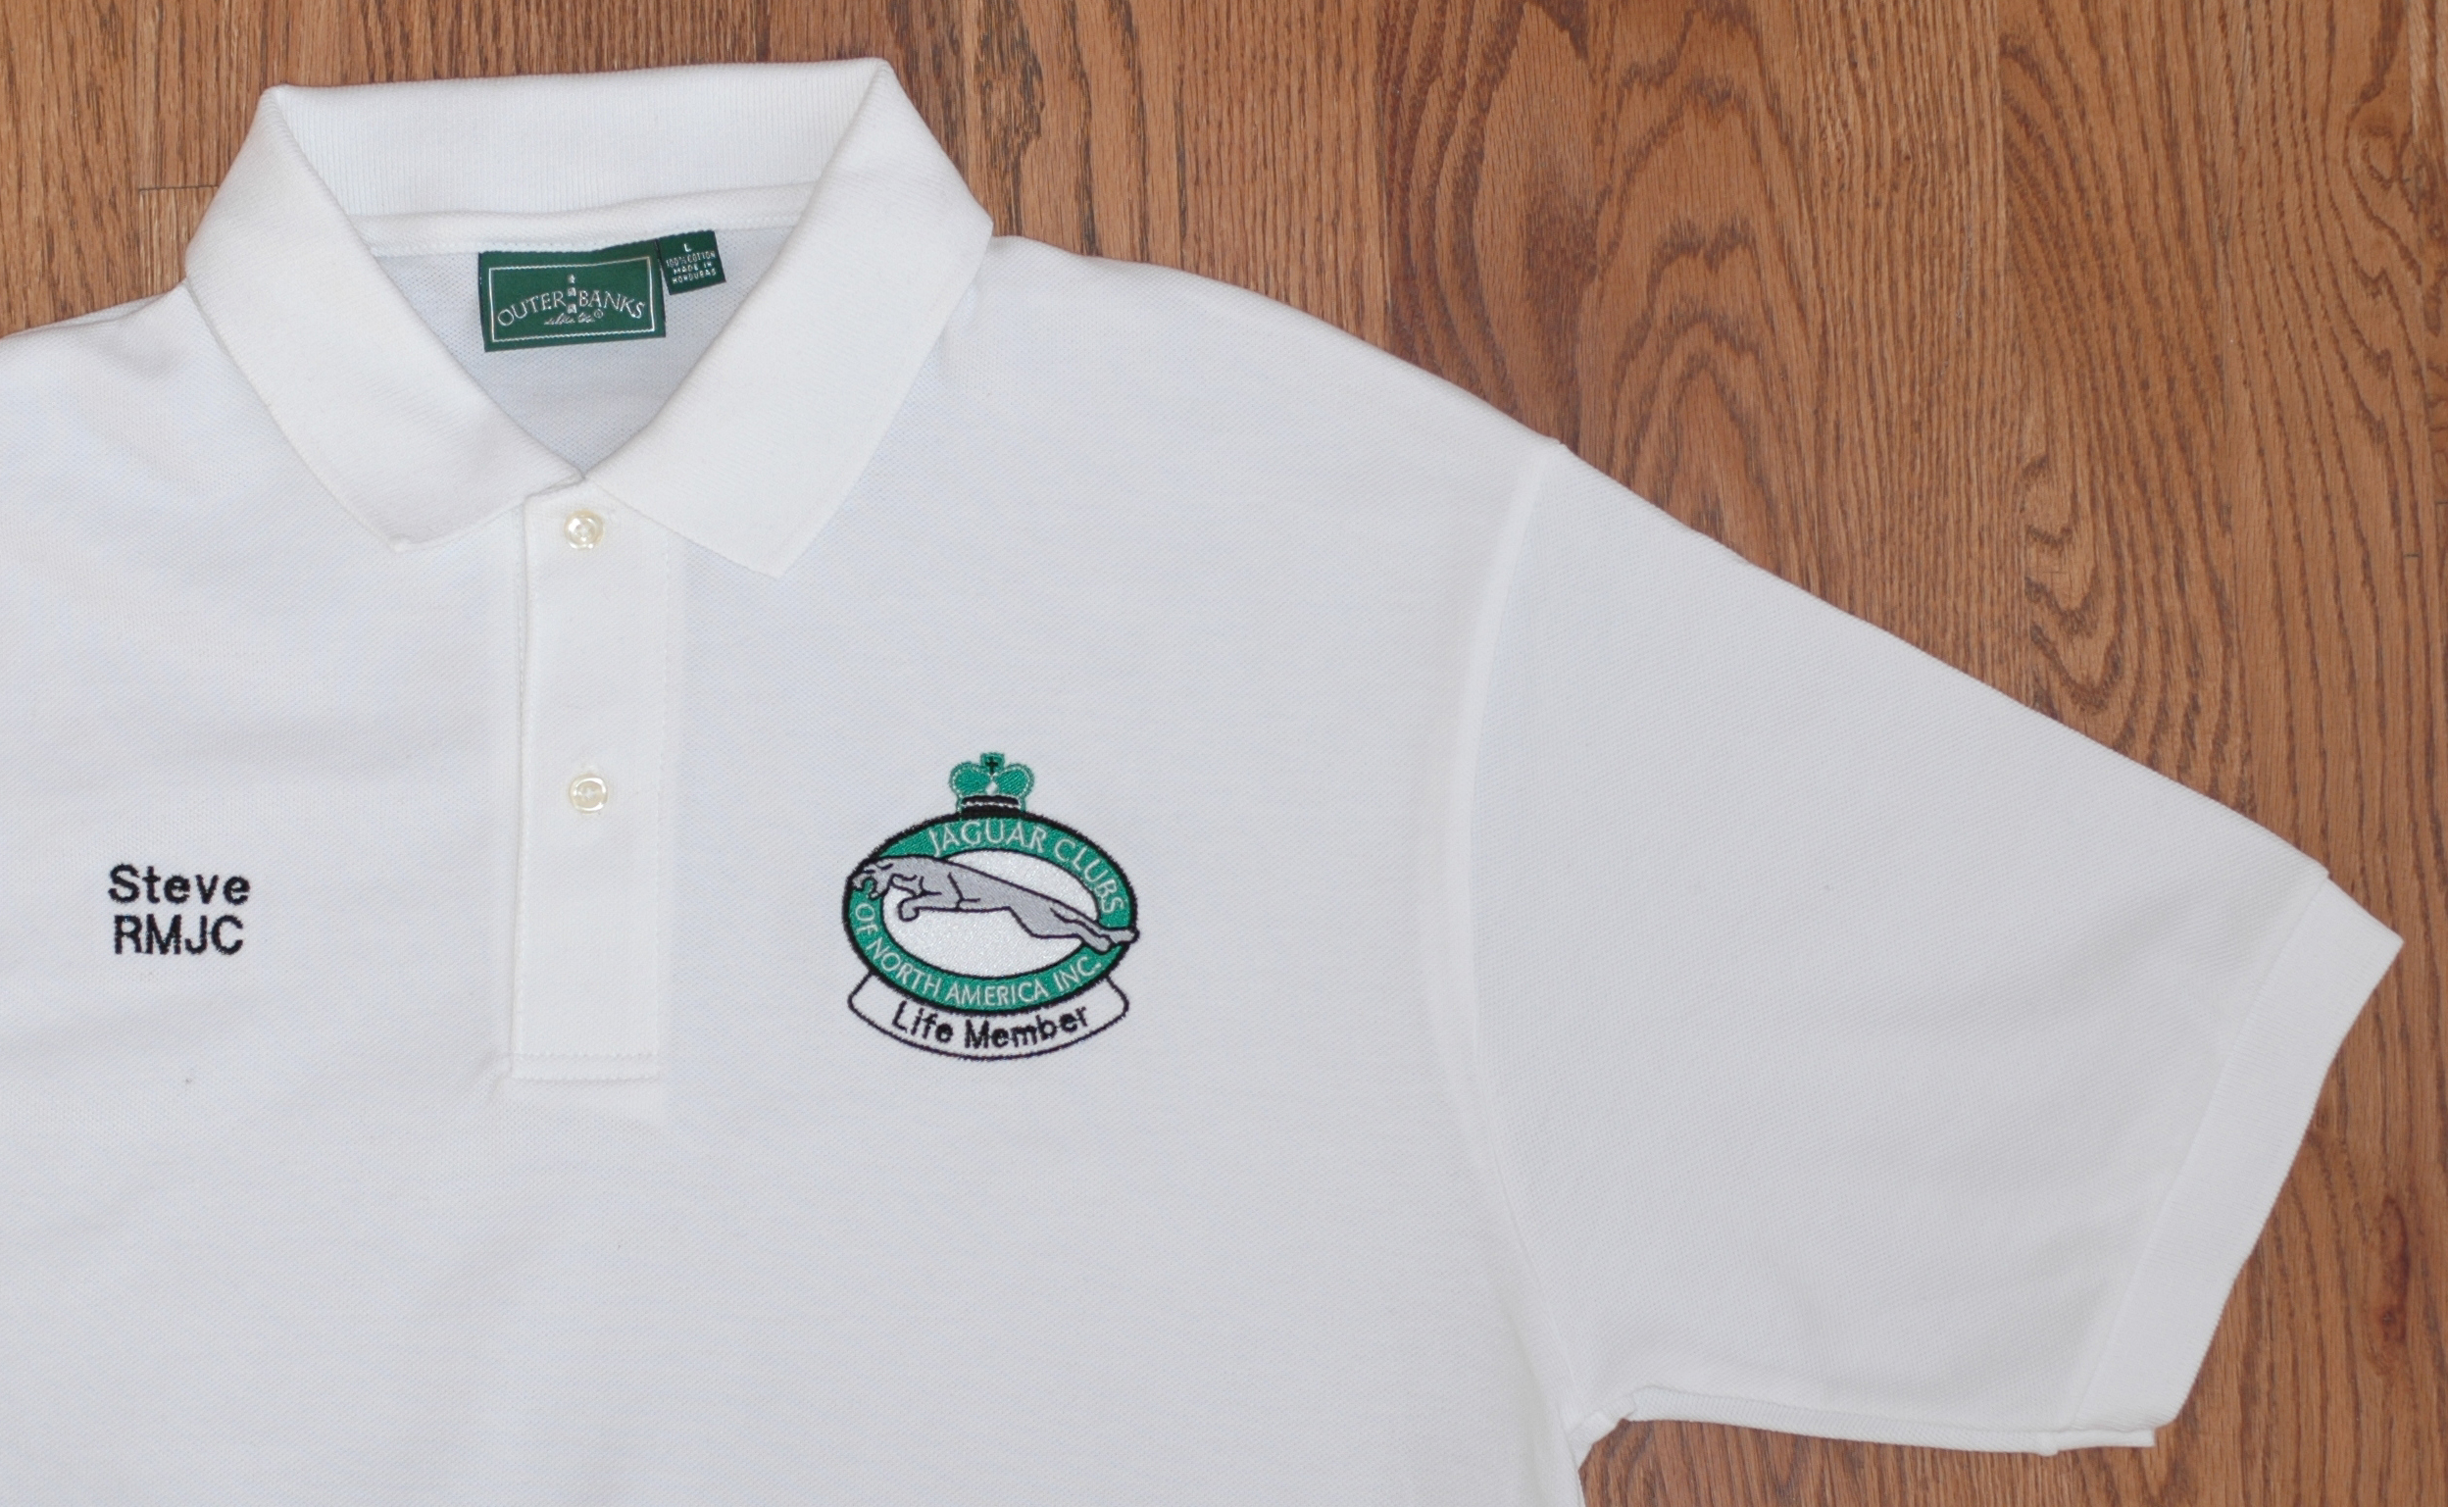 |  | 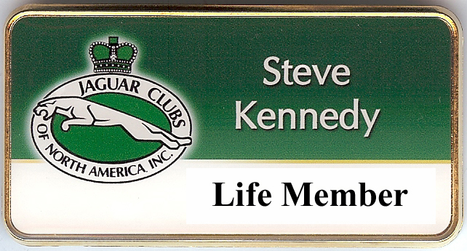  3 inch by 1 ½ inch Name Tag 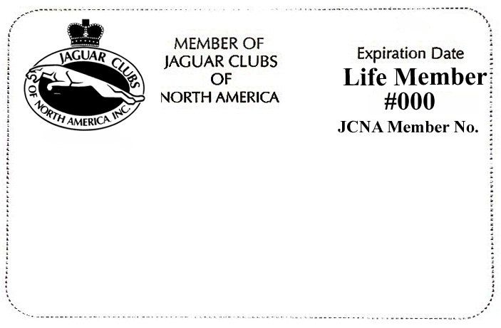
Polo Shirt with JCNA Logo and Life Member |  | Laminated Life Membership Card
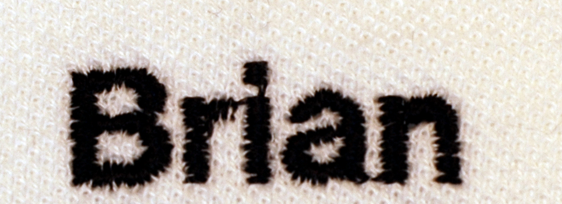 |  | 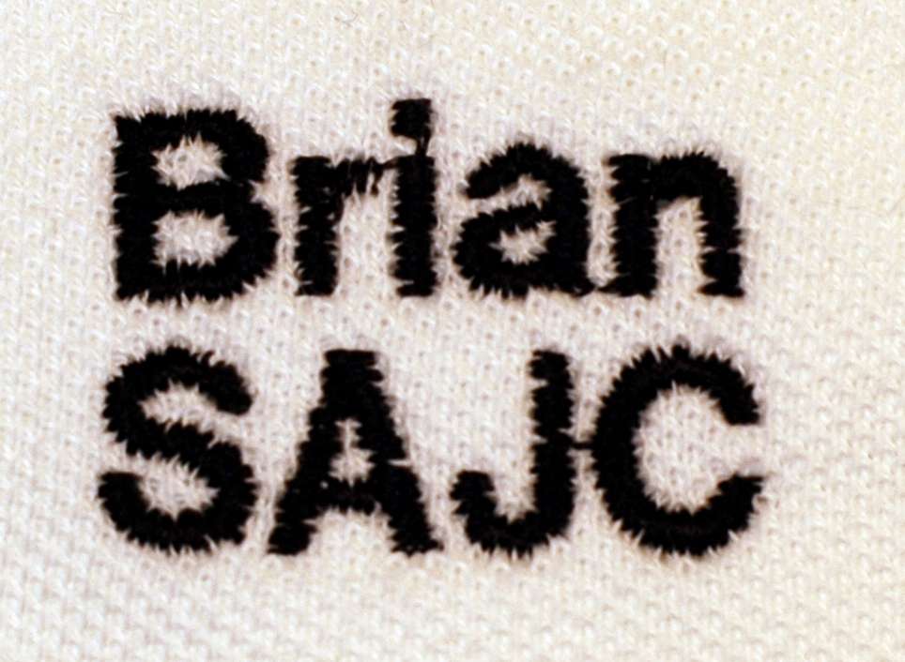
Optional Name on Shirt, No Charge |  | Optional Name and Club Initials  on Shirt, No Charge
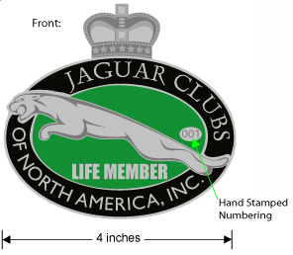 |  | 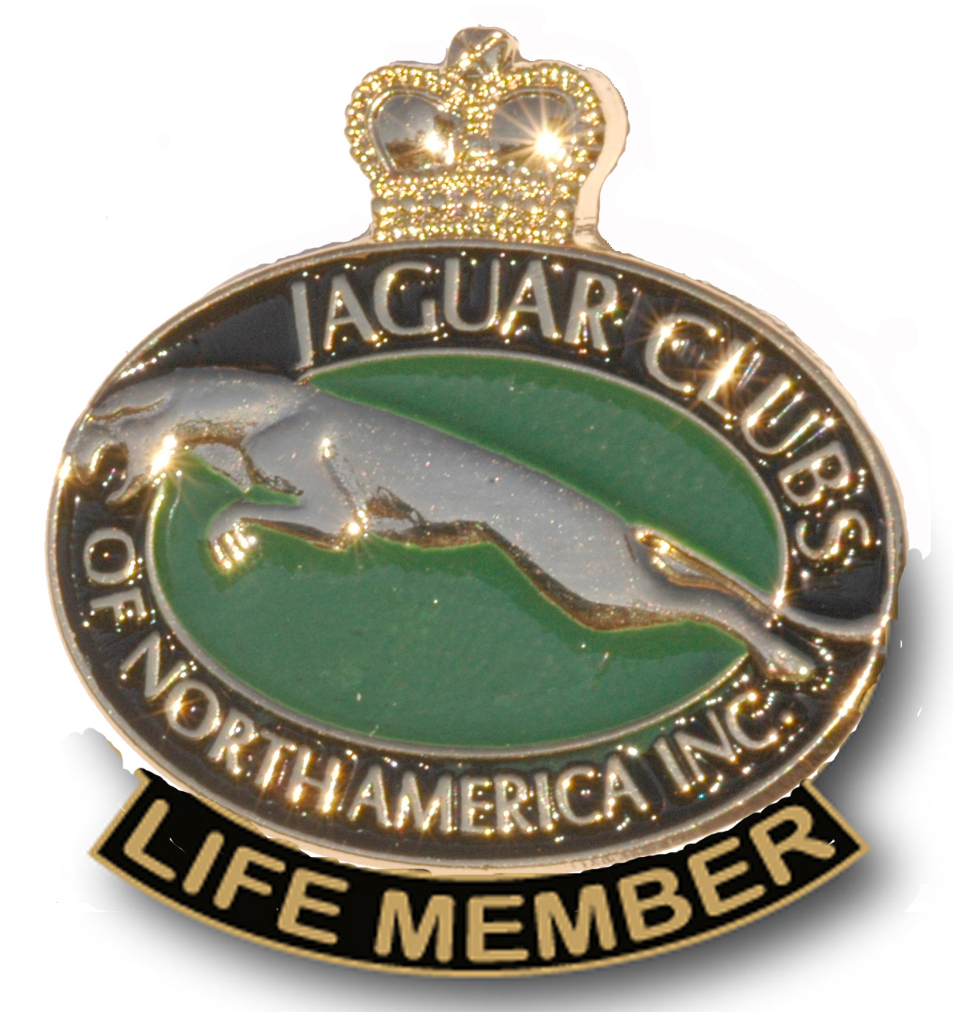
4 Inch Car Badge |  | 1 ½ Inch Lapel Pin

Name: |  |  |  |  |  |  |  |  | Shirt Size
Indicate Name for Optional Name on Shirt: |  |  |  |  |  |  |  | Indicate Optional Club Initials on Shirt:
I authorize JCNA to debit my credit card for $500 |  |  |  |  |  |  |  | Signature
Address: |  |  |  |  |  |  |  | Visa/ MC #
City, State Zip: |  |  |  |  |  |  |  | Expiration Date:
JCNA Number: |  |  |  |  |  |  |  | Phone:
 |  |  |  |  |  |  |  | Email:
You may join on line by going to JCNA.com, Shoppe, Merchandise and look for 19-LIFE-MEM, JCNA Life Membership Program
Or mailing this form to Deanie Kennedy, JCNA Membership Chair, 8137 Zang St., Arvada, CO 80005-5190, Or Call 888-258-2524 #1

