SEATTLE JAGUAR CLUB SLALOM
JCNA-sanctioned
September 7th, 2019
Emerald Downs, Auburn, WA

Come join the Seattle Jaguar Club at Emerald Downs for a JCNA-sanctioned slalom.
JCNA Sanctioned
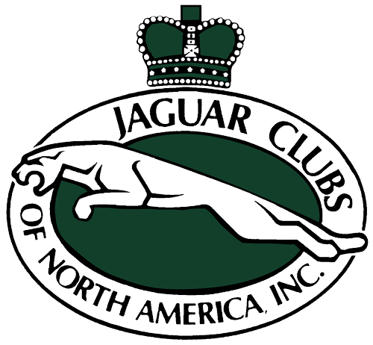
Entry fee $35
non-JCNA members
$5 additional insurance fee

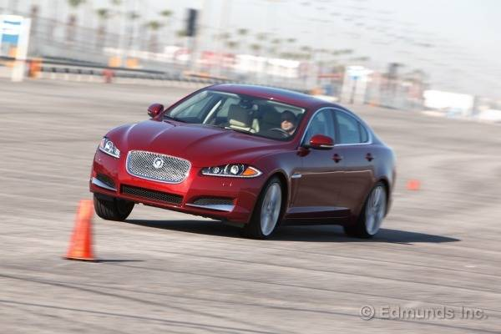
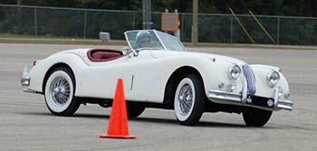
For more information contact

Bob Book at bbook939@gmail.com
253-293-1050

Food and lodging is located nearby for those that are staying the night.

RenoJaguarClub.com

