2017 Virginia Jaguar Club Concours

TWO JCNA CONCOURS EVENTS IN ONE WEEKEND JUST A 2.5 HOUR DRIVE APART!
This year’s VJC Concours returns to the Wyndham Virginia Crossings Resort and is one of two JCNA sanctioned Concours events in Virginia the same weekend. The resort is a fantastic location, that hosted our successful AGM and Challenge Championships. For those unfamiliar with Virginia Crossings, it serves as a great venue featuring a colonial theme and several dining options.
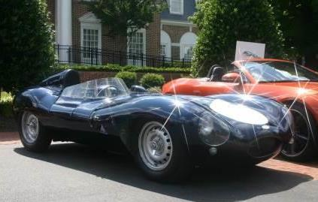
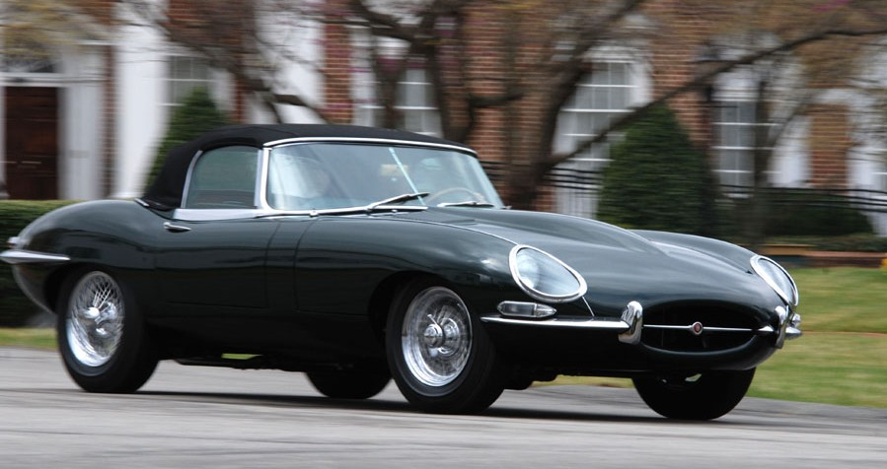
The Concours itself will be on the Madison Lawn overlooking the pool Saturday morning. We moved the schedule up an hour so that the formal judging will be over in time for the participants travel to the NCJOC Concours the next day in Purcellville VA at the 868 Estate Vineyards. For those not attending both Concours, participants of the VJC event are also welcomed to participate with the pre-show events of Classics on the Green, which includes a scenic drive Saturday afternoon. Please join us for a poolside reception and awards ceremony in the afternoon.
Please mention the Jaguar Club Concours for special rooms rates. We have a limited block of rooms, so please call early. On-site trailer parking is also available. Preference will be given to those who register early as well.
Hotel information for the VJC Concours is http://www.wyndhamvirginiacrossings.com/ 804-727-1400
TO REGISTER, PLEASE VISIT www.VJC2017Concours.Eventbrite.com

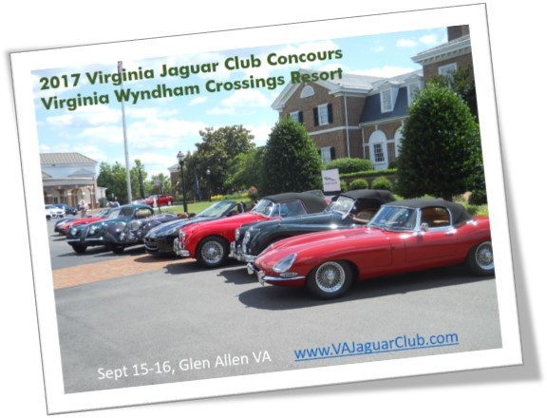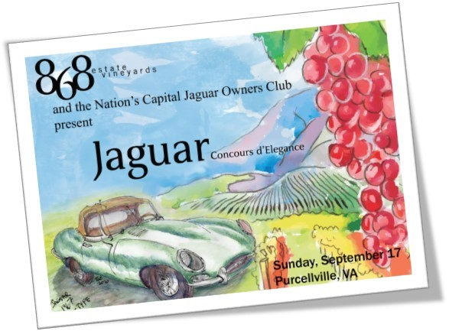
For more information concerning the NCJOC Concours, please see http://www.jcna.com/users/ne40
Details (subject to change):
Friday Sept 15th
Welcome reception on the tavern deck
Saturday Sept 16th
Concours (display and Judges) 8:00 – 1:00 pm
Historic drive in association with Classics on the Green 1:00 – 3:00 pm (optional for those wishing to participate)
Poolside cocktail reception and awards ceremony 2:30 – 3:30 pm *grab and go lunches as well as dining in the Tavern are available for lunch.
Sunday Sept 18th (two great options!)
NCJOC Concours at 868 Vineyards in Purcellville VA
Classics on the Green car show and wine festival at New Kent Winery (for those not planning on attending the NCJOC Concours at 868 Vineyards)
*Registration for Classics on the Green is separate if you plan on attending the show, please register at http://www.classicsonthegreen.com/
For additional information, please visit the VJC website www.VAJaguarClub.com
Look forward to seeing everyone there!

