Jaguar Affiliates Group of Michigan
Invites You to Join Our Concours d’Elegance
and all New British Showcase
Saturday Sept 5, 2020

Olde World Canterbury Village,
2359 Joslyn Ct., Lake Orion, Michigan 48360
http://canterburyvillage.com/index.php
All the cars will be displayed on the grass between the shops and cottages.
This is JAGM‘s most prestigious event, the JCNA-sanctioned Jaguar Concours d’Elegance, will be held at this small and unique old-time village. We would like to invite all the other British Marques to join us for the day in a New British Showcase. All the cars will be displayed on the lawn between the shops and cottages.
Each Marque will have their own area to park their cars for display and will be expected to park their cars as you see fit by model, year or random. You can run your portion of the show as you see fit. You can have a Concours, popular vote of your own or go around laughing at the cars that needed to get all dressed up for the day.
Trailer parking if needed is in the North Parking Lot at Canterbury Village.
The event site opens for all entrants at 9:00AM. All cars must enter the Village from the North Driveway. You will pass through a registration area and will be pointed to the vicinity of your Marque’s parking.
Jaguar Troy may have some new cars, and possibly some used cars, on display for you to check out. Plan on stopping by to view the new and used JLR’s vehicle selections and offerings.
A hospitality tent will be available during the day for respite from the sunny weather. Bottled water will be available. There are also plenty of small shops to visit. These venues will offer you a break from the weather and will also provide options to entertain your guests.
Lunch may be purchased at the C-Pub Bar & Grill or snacks at Yates Cider Mill.
There will be an informal early dinner starting at 4:00 on the patio outside the C-Pub, followed by the Awards presentations, including a slide show of the day’s activities and participants.
There will be an entry price of $10 for the British Cars to cover insurance for the weekend and a dash plaque per car until we run out.

Host Hotel
Our host hotel is the Springhill Suites, 4919 Interpark Drive, Orion Twp., MI 48359
Tel: (248) 475-4700
https://www.marriott.com/hotels/hotel-photos/dtwra-springhill-suites-detroit-auburn-hills/
The hotel is basically on the corner of Lapeer and Dutton Roads, just 5 miles from Canterbury Village
A block of rooms is reserved for JAGM members. Room rate will be $109 per night for 2 Queens or 1 King bed. Full fare rates are $159 and $169. Please call the hotel direct and mention ‘Jaguar Club’ when making your reservation. This is very important as they do monitor how many of our rooms we book! Please be careful of third party web sites that may not recognize the special rates. Continental breakfast is included and served in the morning.
A reserved parking area, and trailer parking, will all be available.
You will also have access to the indoor swimming pool and fitness center.
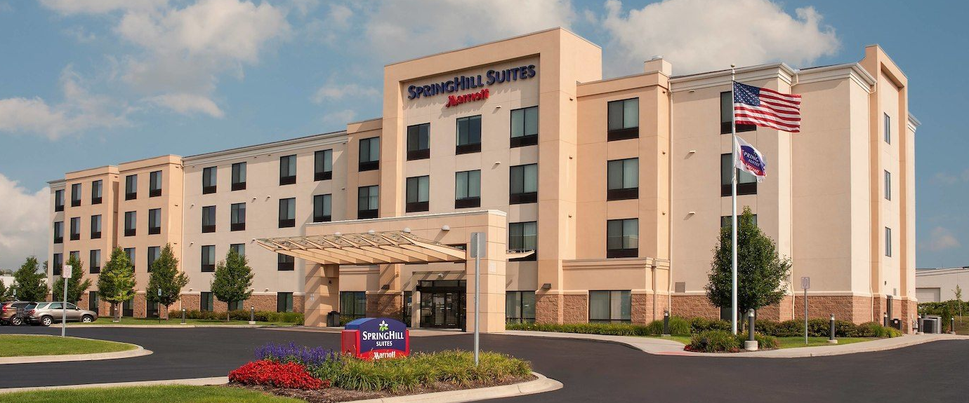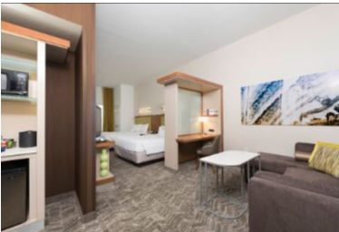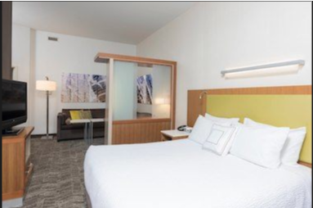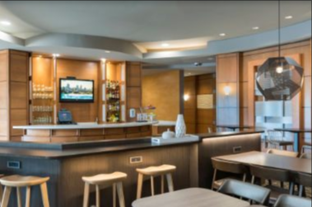

Join Us for Friday Night Hospitality
A hospitality reception will be held in the hotel lobby, breakfast area and bar starting at 6:00 PM. Come and meet friends old and new. A light meal will be provided, and bar service will be available. Local JAGM members are encouraged to attend and bring a dish from home to share.
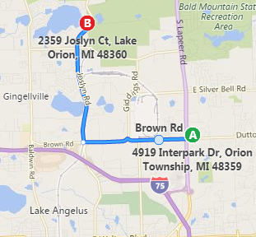
The Concours d’Elegance is located on the north side of the Detroit area.
Canterbury Village is off the I-75 expressway at Exit 81 (Lapeer Road North) near the Palace, and at Exit 83, (Joslyn Road North) near the “Great Lakes Crossing” shopping mall.

