Jaguar Affiliates Group of Michigan
Invites You to Join Us at Our 52nd
Jaguar Concours d’Elegance
Saturday Sept 5, 2020

Olde World Canterbury Village, 2359 Joslyn Ct., Lake Orion, Michigan 48360

http://canterburyvillage.com/index.php
JAGM‘s most prestigious event, the JCNA-sanctioned Jaguar Concours d’Elegance, will be held at this small and unique old-time village. The cars will be displayed on the lawn between the shops and cottages. This year we will invite other British Marques to join us in a British Showcase. Come and Join the FUN!
Join us and show your pride in the marque whether you have a classic, or a brand-new E, F or I-Pace. There will be formal judged events in both Championship and Driven JCNA classes. Prefer not to be judged? No problem! Come and join in the display class, where everyone can admire your car without the work!
Trailer parking is in the North Parking Lot at Canterbury Village.
Jaguar Troy may have some new cars, and possibly some used cars, on display for you to check out. Plan on stopping by to view the new and used JLR’s vehicle selections and offerings.
A hospitality tent will be available during the Concours for respite from the sunny weather. Bottled water will be available. There are also plenty of small shops to visit. These venues will offer you a break from the weather and will also provide options to entertain your guests.
Lunch may be purchased at the C-Pub Bar & Grill or snacks at Yates Cider Mill.
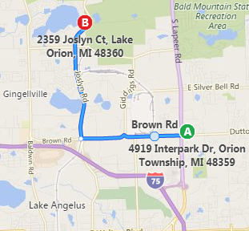
There will be an informal early dinner on the patio outside the C-Pub, followed by the Awards presentations, hopefully including a slide show of the day’s activities and participants.
This year’s Concours d’Elegance is located on the north side of the Detroit area.
Canterbury Village is off the I-75 expressway at Exit 81 (Lapeer Road North) near the Palace, and at Exit 83, (Joslyn Road North) near the “Great Lakes Crossing” shopping mall.
Jaguar Affiliates Group of Michigan
52nd Annual
Jaguar Concours d’Elegance
Event Details

Host Hotel
Our host hotel is the Springhill Suites, 4919 Interpark Drive, Orion Twp., MI 48359
Tel: (248) 475-4700
https://www.marriott.com/hotels/hotel-photos/dtwra-springhill-suites-detroit-auburn-hills/
The hotel is basically on the corner of Lapeer and Dutton Roads, just 5 miles from Canterbury Village
A block of rooms is reserved for JAGM members. Room rate will be $109 per night for 2 Queens or 1 King bed. Full fare rates are $159 and $169. Please call the hotel direct and mention ‘Jaguar Club’ when making your reservation. This is very important as they do monitor how many of our rooms we book! Please be careful of third party web sites that may not recognize the special rates. Continental breakfast is included and served in the morning.
A reserved parking area, trailer parking, car washing facilities and overnight security will all be available. You will also have access to indoor swimming pool and fitness center.
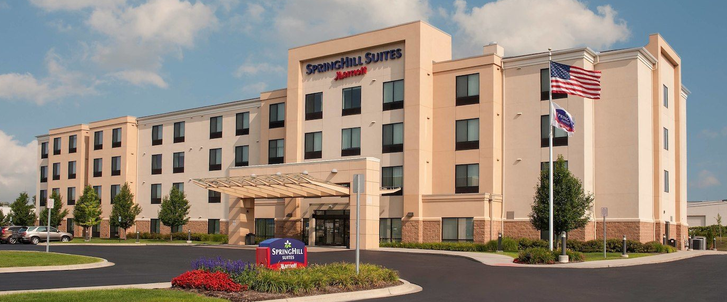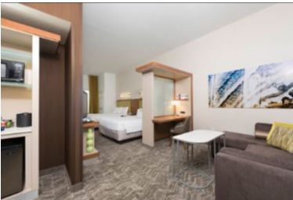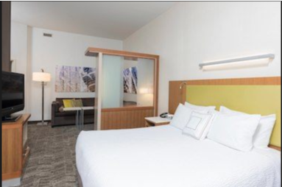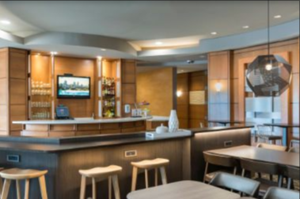

Join Us for Friday Night Hospitality
A hospitality reception will be held in the hotel lobby, breakfast area and bar starting at 6:00PM. Come and meet friends old and new. A light meal will be provided, and bar service will be available. Local JAGM members are encouraged to attend and bring a dish from home to share.

Jaguar Concours d’Elegance Schedule:
09:00 AM Event site opens for entrants
All cars enter the North driveway and will pass the Registration tent followed by
the OV Checks, also on the driveway, prior to reaching your judging position.
11:00 AM—12:00 PM Judges Luncheon Meeting
12:00 PM Rags down
12:00 PM Judging begins
Participants in Championship and Driven classes must be at their cars
03:00 PM Latest expected release of cars by Chief Judge
04:00 PM Informal Dinner and Awards on the patio outside the C-Pub

Registration Form
Name
Partner Name
Address
City, State, Zip
Home Phone
Cell Phone
E‐Mail
JCNA Aﬃliation
JCNA Number

Jaguar Affiliates Group of Michigan
52nd Concours d’Elegance Saturday, Sept 5, 2020
Concours d’Elegance entries are open to all Jaguar Owners and Jaguar powered Jaguar Cars. Entries in all Championship Division classes and all Driven Division classes are judged according to JCNA rules approved for the current year.
ALL Championship and Driven class entries must be received by August 29, 2020.
Registration Fees:
- Championship Division: $50  Driven Division: $50  Additional Car, either division: $40  Display: $25
- Display registration will be accepted on the day of show until 11:00 AM for $30.
- If you are not a JCNA member we are required to charge a $5 insurance fee.
- For out-of-town JCNA Members: I am a Certified JCNA Concours Judge and will be available to Judge in Michigan.
Name________________________________ JCNA Number _________________ Preferred Class:____________
Year | Model | Body Style | Color |  | Class |  | Fee
 |  |  |  |  |  |  | $
 |  |  |  |  |  |  | $
 |  |  |  | Pub Early Dinner & Awards, ala cart
 |  |  |  | Non‐JCNA Member $5 Insurance Fee |  |  | $
 |  |  |  | Total Enclosed |  |  | $

Mail completed form, together with check or money order (payable to Jaguar Aﬃliates Group of Michigan), for total amount to:
Jaguar Aﬃliates Group of Michigan c/o Pauline Blunt
4715 Bell Oak Road, Williamston, MI 48895 USA
Release of Liability
JCNA event participation: It is an entrant’s privilege to participate in any JCNA sanctioned event held by any JCNA aﬃliate upon executing proper registration forms and paying published entrance fees. Each aﬃliate shall be solely responsible for granting entry privileges to each entrant on an individual basis.
I hereby agree to enter the above described Jaguar(s) in the JAGM Concours d’Elegance. In consideration of the right and privilege to enter and participate and other valuable consideration, and intending to be legally bound, I agree to release the Jaguar Clubs of North America (JCNA), Jaguar Aﬃliates Group of Michigan (JAGM) and the Concours d’Elegance committee from all liability for injuries, damage or loss arising from my entry and attendance in the Concours d’Elegance. My vehicle has full Liability Insurance.

Signature of Jaguar Owner Date

_____________________________________________________ ____________________________________
Your Jaguar Auto Insurance Company Policy Number

 | JCNA Concours Classes
Championship Classes |  | Driven Classes
C1/PRE | Classics (Pre-XK engine) Tourer, OTS, DHC and Saloons: Swallow, SS & SS Jaguar ('27-51) | D1/PRE
next | All Classics (Pre-XK engine) and XK 120, XK 140, XK 150 | D1/PRE
C2/120 | XK 120 (1948-54) | D1/PRE
C3/140 | XK 140 (1955-57) | D1/PRE
C4/150 | XK 150 (1957-61) | D1/PRE
C5/E1 | E-Types, Series 1 (1961-67) | D2/E1
C6/E2 | E-Types, Series 1.5 (1968) and Series 2 E-Types (1968-71) | D3/E2
C7/E3 | E-Types, Series 3 (1971-75) | D4/E3
C8/SLS | Early Large Saloons: MK VII, MK VIII, MK IX, MK 10, 420G, (1950-70);  Early Small Saloons: MK 1 (2.4 & 3.4), MK 2 Series (2.4, 3.4, 3.8 liter, V8)  240, 340; S-Type 3.4S, 3.8S, & Jaguar and Daimler 420 (1955-69) | D5/SLS
C9/XJ | XJ6/12 Series 1 Saloons (1968-73); XJ6/12 Series 2 Saloons and Coupes (1973- 79); Series III XJ6, XJ6 Sovereign and XJ6 VDP (1979-87); Series III V12 and V12 VDP (1979-92) | D6/XJ
C10/XJ | XJ6 (XJ40) Sedans (1987-94), XJ12 (XJ81) (1993-94); XJ6/12/R, (X300/X305) (1995-97) | D7/XJ
C11/J8 | XJ8/R Sedans (X308) (1998-2003), XJ8/R Sedans (X350 Alloy) (2004-2009) | D12/J8
C12/JS | XJ-S/SC (1976 - 1991 Pre-Facelift) | D8/XJS
C13/JS | XJS (1991 - 1996 Facelift) | D9/XJS
C14/K8 | XK8 Coupe and Conv. (1996-2006), XKR (1999-2006) | D10/K8
C15/XK | XK and XKR Coupe and Conv. (2007-On) | D11/XK
C16/SX | S-TYPE Sedans (1999-2008), X-TYPE Sedans and Estate Wagon (2002-2008) | D13/SX
C17/PN | Preservation Class (more than 35 years old) | none
C18/PN | Preservation Class (20 to 35 years old) | none
C19/FJ | XF Sedans (2008-On), XJ Sedan (2010 - On), XE (2016-On) | D14/FJ
C20/F | F-TYPE (2013-On) | D15/F
C21/P | F-PACE (2016-On), E-Pace, I-Pace (2018-On) | D16/P
 | Factory and Privately Prepared Competition Cars | S1/PD
 | Modified | S2/MOD
 | Replica (non-production, Jaguar powered) | S3/REP

7/16/20

