Carolina Jaguar Club Concours
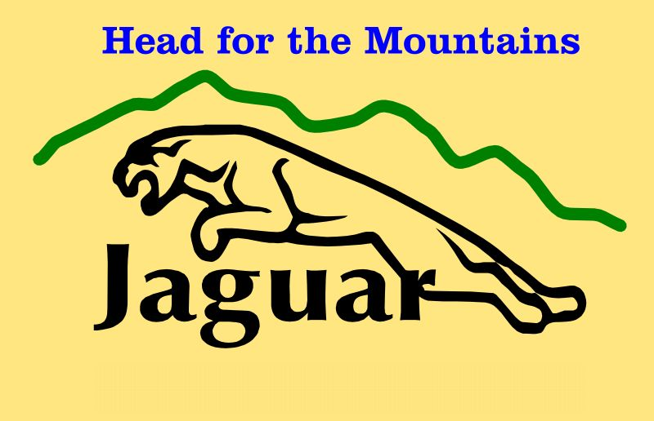
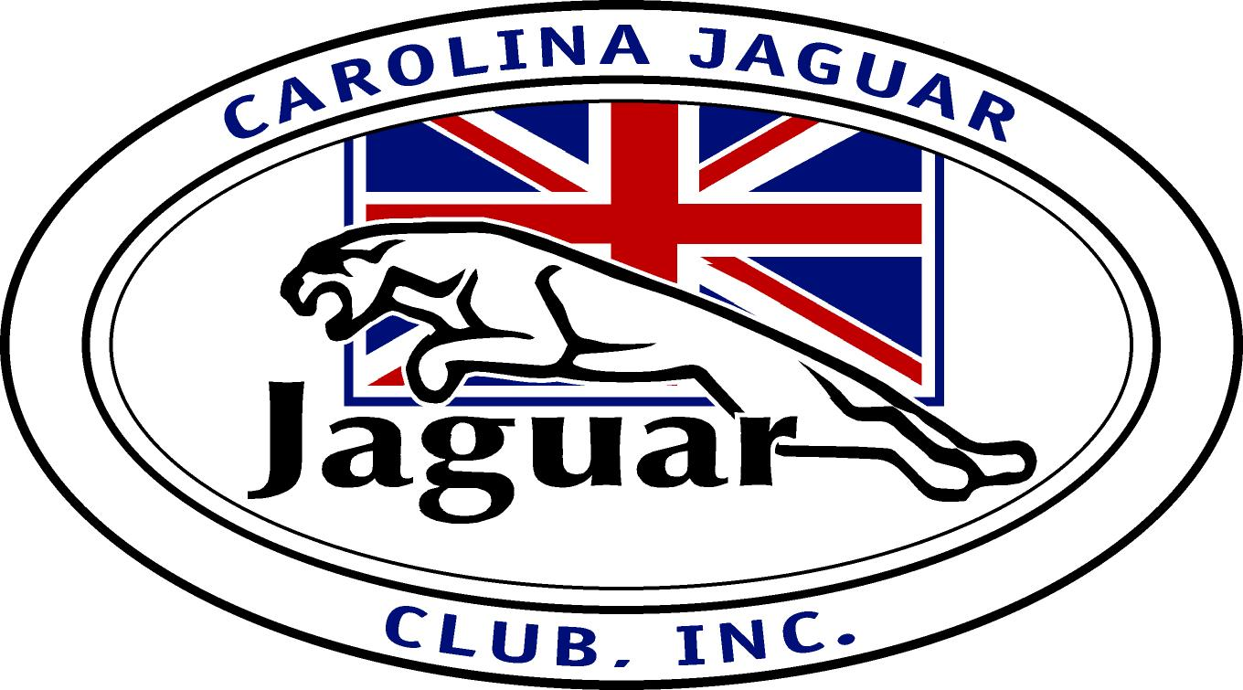

HEAD FOR THE MOUNTAINS
July 22-25, 2021
Little Switzerland, NC

Head for the Mountains with the Carolina Jaguar Club for its 2021 Concours in the lovely Blue Ridge Mountains of North Carolina. This is a sanctioned JCNA concours event, judged by rules at www.jcna.com.

The Concours is held at the Switzerland Inn in Little Switzerland, North Carolina. The Switzerland Inn offers a lovely setting on the crest of the Blue Ridge Mountains and is just a few hundred yards from the Blue Ridge Parkway near mile post 334. You will enjoy beautiful vistas and a relaxing setting as there is a 100% chance of cooler temperatures at this mountain top location versus what you will be experiencing down in the “flatlands” in July! Check out www.Switzerlandinn.com for more information about the Inn.

The Carolina Jaguar Club has held their annual JCNA sanctioned Concours at the Switzerland Inn for several years now and offers a full range of activities. In fact, this event has been called one of the finest Jaguar concours in the nation.
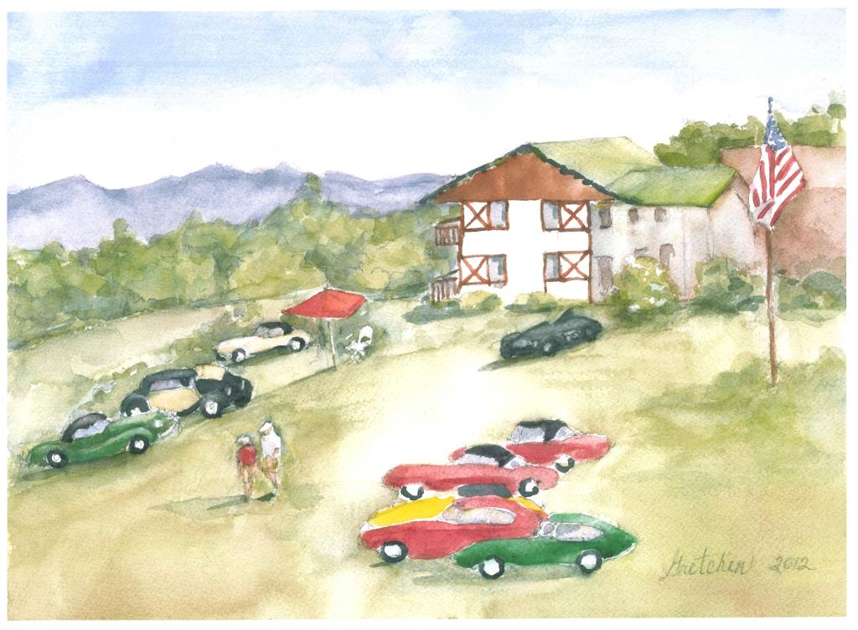
Plan to arrive on Thursday evening to join other attendees at a relaxed Thursday night gathering.. Meet old friends and make new ones.

There is no more fun location to exercise your Jaguar than the Blue Ridge Mountains. You can do just that on Friday morning as we have a drive event planned for your enjoyment. Participants will start leaving the Switzerland Inn about 9 a.m., following a set of directions. The morning drive will take you through beautiful national forests and past rural farms of the Blue Ridge Mountains. A wonderful luncheon is planned, followed by a return to the Inn along the Blue Ridge Parkway. Scheduling will allow you plenty of time Friday afternoon to prepare your car for Saturday’s concours.

Friday evening, join us on the patio for a sponsored cocktail party. Afterwards, you may wish to join us as we try out Switzerland Inn’s surf and turf. This is an informal get together. A cash bar will be available. Following dinner, there will be a general interest presentation.

Saturday is our main event, the Concours. Entrants should note that washing stations will be provided both Friday afternoon and Saturday morning. The show field will be open to the general public with no entry charge on Saturday. For Saturday lunch, order à la carte in the Switzerland Inn restaurant.

Every JCNA member who attends the show on Saturday will be able to cast their vote for the Isabel Parish Memorial People’s Choice car award.

Saturday evening, is our gala banquet and awards ceremony, which will be preceded by a sponsored cocktail party. We will announce the winners in the various Concours categories, as well as the Popular Choice winner.

Sunday attendees are on their own to spend the day as they wish. You will not want to sleep in too late, as there are some great twisty and scenic driving roads in the area that beg to be explored in your Jaguar. The Little Switzerland area has a number of shops to vie for your attention. The tallest peak east of the Mississippi, Mount Mitchell, is an easy drive down the Blue Ridge Parkway. It may seem like cheating but you can drive right to the top! Other major NC mountain attractions, such as Grandfather Mountain, the Boone-Blowing Rock area, Linville Falls, Asheville, and the Biltmore Estate are nearby as well.

If you enjoy JCNA concours, you will certainly not want to miss this one!

Mark your calendars.

Additional details and registration is available at www.carolinajaguarclub.com.

