2021 RMJC Concours Registration  Name: _______________________________  Address: _____________________________  City: ___________ State: ___ Zip: _______  Home Phone: _________________________  Cell Phone: __________________________  Email: ______________________________  JCNA Number: ______________________  Vehicles To Register:  Year Model Body Color Class  _____ ______ _______ ______ _______  _____ ______ _______ ______ _______  _____ ______ _______ ______ _______  I have attended and/or passed a 2021 certified JCNA judging school test and I am willing to judge: Yes  I CANNOT judge the following Concours classes due to entries by me or family, or work done by me on the cars of other entrants:  _________________________________________  Entry Fee includes: Concours Entry Fee, Breakfast and Lunch.  Entry Fees Due no later than June 20th  All Events One person, One Judged Car $65 _____  All Events One person, One Display Car $45 _____  Additional Person (or just person, no car) $25 _____  Additional Cars $35 _____  Total $ _______  I hereby agree to enter the Jaguar(s) listed on this form in the 2021 Rocky Mtn. Jaguar Club’s “The Sweet and Easy” Concours. In consideration of the right and privilege to enter and participate in this event and other valuable considerations and intending to be legally bound, I do here by agree to release Jaguar Clubs of North America, Rocky Mountain Jaguar Club, and the City of Wheatridge, CO for any liabilities or injuries, damages or loss arising from my entry and attendance at this Concours.  _________________________ __________  Signature Date:  _________________________ __________  Spouse/Guest Signature Date: | Concours Location  From I-70, take the Kipling exit, go south to 44th Avenue, go west to Anderson Park on the south side of 44th. Enter park and drive south to the end of the park.  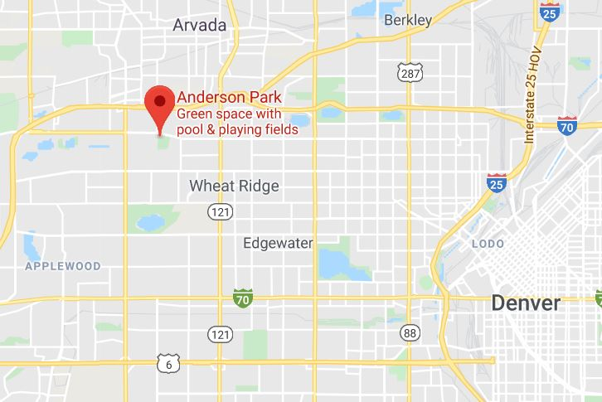  Car Wash:  Pipeline Car Wash  7980 W. 44th Ave.  Wheat Ridge  303-641-3626 | THE 2021 RMJC  SWEET AND EASY CONCOURS  Sunday, June 27, 2021  Anderson Park  Wheat Ridge, CO 80033  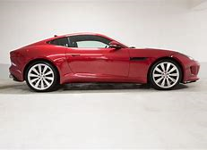  Contact Information:  Frank Sullivan, flsullivan1@comcast.net  970-460-0307  970-226-1194 cell  Steve Kennedy, skennedy@ecentral.com,  303-489-3955  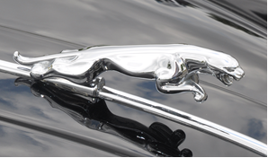
2021 Rocky Mountain Jaguar Club  Concours d’Elegance  ANDERSON PARK  WHEAT RIDGE, CO  Sunday, June 27th  Schedule:  Open at 8:00 am  Coffee & Donuts/Breakfast 8:00-9:30  Rags Down at 10:00  Judging 10:15-1:00  Lunch 11:30-1:00  Awards: Immediately After Lunch  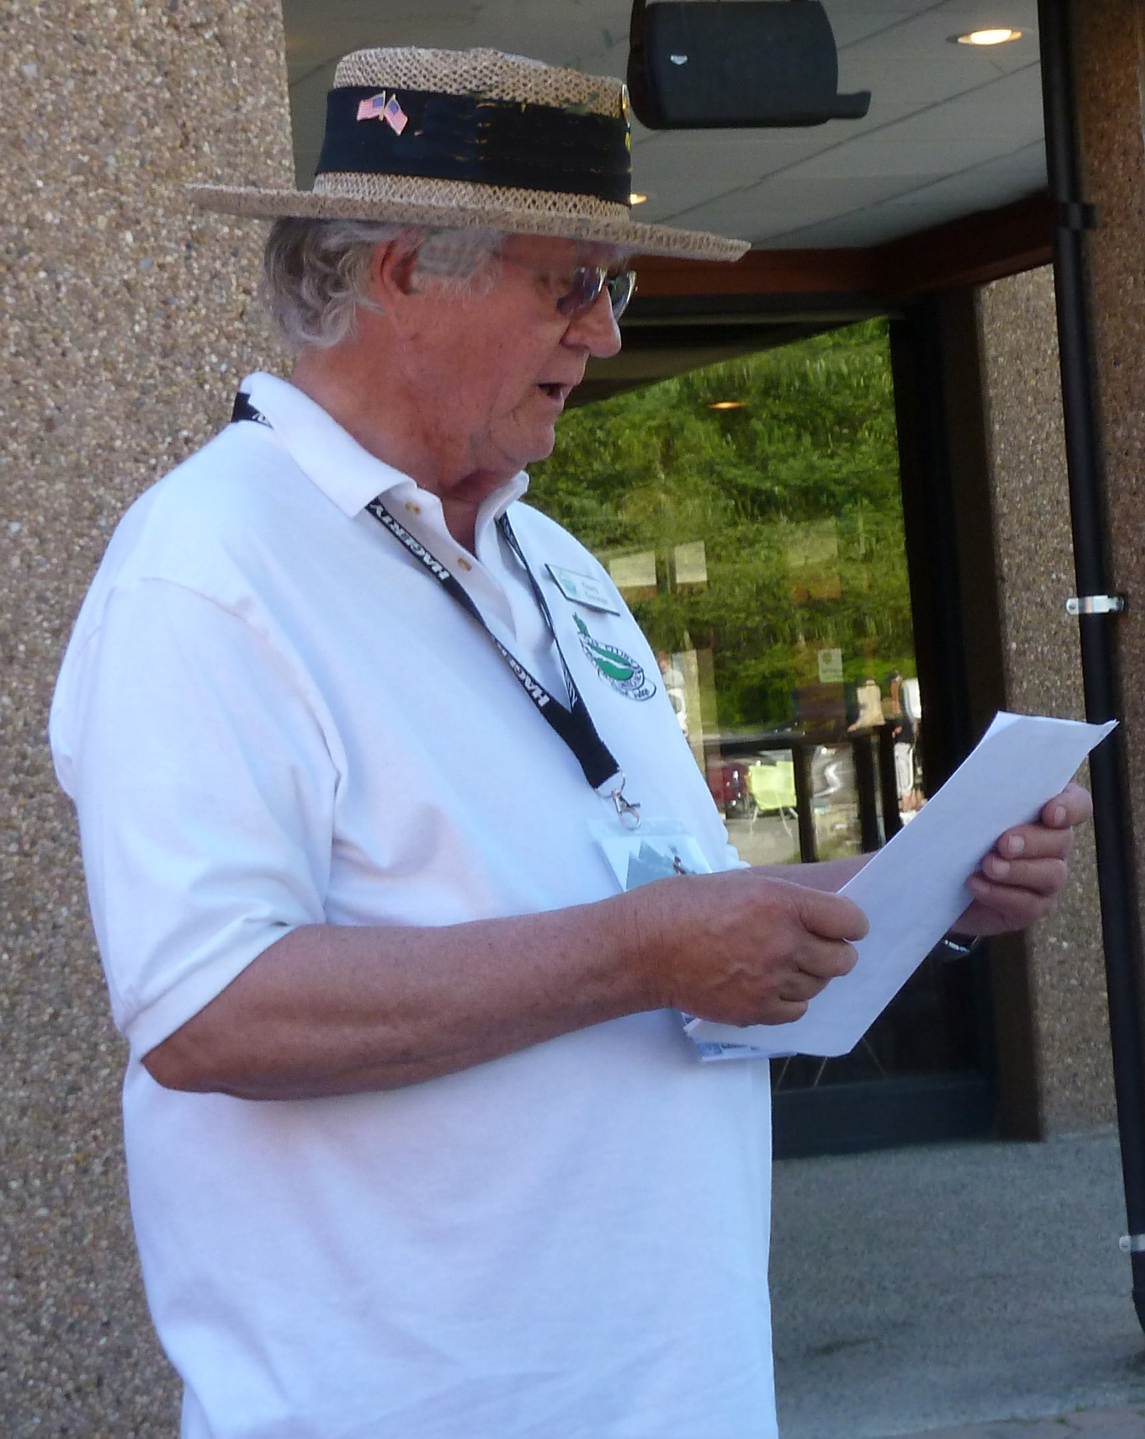  Judging at 10:15  Hotel Information  Holiday Inn Express (.8 mi) $98  10101 West 48th Avenue, Wheat Ridge  844-650-2100  Hilton Garden Inn (1.7 mi)  5455 Olde Wadsworth Blvd, Arvada, $107  303-420-9799 | CHAMPION DIVISION CLASSES  C1/PRE: Classics (Pre-XK engine) Tourer, OTS, DHC and Saloons: Swallow, SS & SS Jaguar (1927-51)  C2/120: XK 120 (1948-54)  C3/140: XK 140 (1955-57)  C4/150: XK 150 (1957-61)  C5/E1: E-Types, Series 1 (1961-67)  C6/E2: E-Types, Series 1.5 (1968) and Series 2  E-Types (1968-71)  C7/E3: E-Types, Series 3 (1971-75)  C8/SLS: Early Large Saloons: MK VII, MK VIII, MK IX, MK 10, 420G, (1950-70); Early Small Saloons: MK 1 (2.4 & 3.4), MK 2 Series (2.4, 3.4, 3.8 liter, Daimler V8), 240, 340; S-Type 3.4S, 3.8S, & Jaguar and Daimler 420 (1955-69)  C9/XJ: XJ6/12 Series 1 Saloons (1968-73); XJ6/12 Series 2 Saloons and Coupes (1973-79); Series III XJ6, XJ6 Sovereign and XJ6 VDP (1979-87); Series III V12 and V12 VDP (1979-92)  C10/XJ: XJ6 (XJ40) Sedans (1987-94), XJ12 (XJ40) (1993-94); XJ6/12/R, (X300) (1995-97)  C11/J8: XJ8/R Sedans (X308) (1998-2003), XJ8/R Sedans (X350 Alloy) (2004-2009)  C12/JS: XJ-S/SC (1976 - 1991 Pre-Facelift) Coupe, Cabriolet, H&E Convertible, Convertible,  XJR-S Le Mans, XJR-S Jaguar Sport.  C13/JS: XJS (1991 - 1996 Facelift) Coupe, Convertible, XJR-S Jaguar Sport.  C14/K8: XK8 Coupe and Conv. (1996-2006), XKR (1999-2006)  C15/XK: XK and XKR Coupe and Conv. (2007-On)  C16/SX: S-TYPE Sedans (1999-2008), X-TYPE Sedans and Estate Wagon (2002-2008)  C17/PN: Preservation Class (more than 35 years old)  C18/PN: Preservation Class (20 to 35 years old)  C19/FJ: XF Sedans (2008-On), XJ Sedan (2010 [as 2011 model year] – On), XE (2016 Model Year)  C20/F: F-TYPE (2013-On)  C21/FP: F-PACE, E-PACE, I-PACE  SPECIAL DIVISION CLASSES  S1/PD: Factory-produced and prepared Competition Jaguars, Factory-sponsored Competition and Limited Production Jaguars and Production Jaguars privately prepared and modified for competition  S2/MOD: Modified  S3/REP: Replica (non-production, Jaguar powered) | DRIVEN DIVISION, CLASSES  D1/PRE: All Classics (Pre-XK engine) and XK 120, XK 140, XK 150  D2/E1: E-Types (1961-67)  D3/E2: E-Types Series 1.5 (1968) and Series 2 E-Types (1968-71)  D4/E3: Series 3 E-Types (1971-75)  D5/SLS: Early Large Saloons: MK VII, MK VIII, MK IX, MK 10, 420G, (1950-70); Early Small Saloons: MK 1 (2.4 & 3.4), MK 2 Series (2.4, 3.4, 3.8 liter, Daimler V8), 240, 340; S-Type 3.4S, 3.8S, & Jaguar and Daimler 420 (1955-69)  D6/XJ: XJ6/12 Series 1 & 2, Saloons and Coupes (1968-79); Series III XJ6, XJ6 Sovereign and XJ6 VDP (1979-87); Series III V12 and V12 VDP (1979-92)  D7/XJ: XJ6 (XJ40) Sedans (1987-94); XJ12 (XJ40) (1993-94); XJ6/12/R, (X300) (1995-97)  D8/XJS: XJ-S/SC (1976 - 1991 Pre-Facelift) Coupe, Cabriolet, H&E Convertible, Convertible,  XJR-S Le Mans, XJR-S Jaguar Sport.  D9/XJS: XJS (1991 - 1996 Facelift) Coupe, Convertible, XJR-S Jaguar Sport.  D10/K8: XK8 Coupe and Conv. (1996-2006), XKR (1999-2006)  D11/XK: New XK and XKR Coupe and Conv. (2007-On)  D12/J8: XJ8/R Sedans (X308) (1998-2003), XJ8/R Sedans (X350 Alloy) (2004- 2009)  D13/SX: S-TYPE Sedans (1999-2008), X-TYPE Sedans and Estate Wagons (2002-2008)  D14/FJ: XF Sedans (2008-On), XJ Sedan (2010 [as 2011 model year] – On), XE (2016 Model Year)  D15/F: F-TYPE (2013-On)  D16/FP: F-PACE, E-PACE, I-PACE)  Make checks Payable to: RMJC  Mail To: RMJC Treasurer  Deanie Kennedy  8137 Zang St.  Arvada, CO 80005  Or register online at: http://www.rockymountainjaguarclub.org/

