JAGUAR ASSOCIATES GROUP
A fun group of Jaguar enthusiasts invites you to:

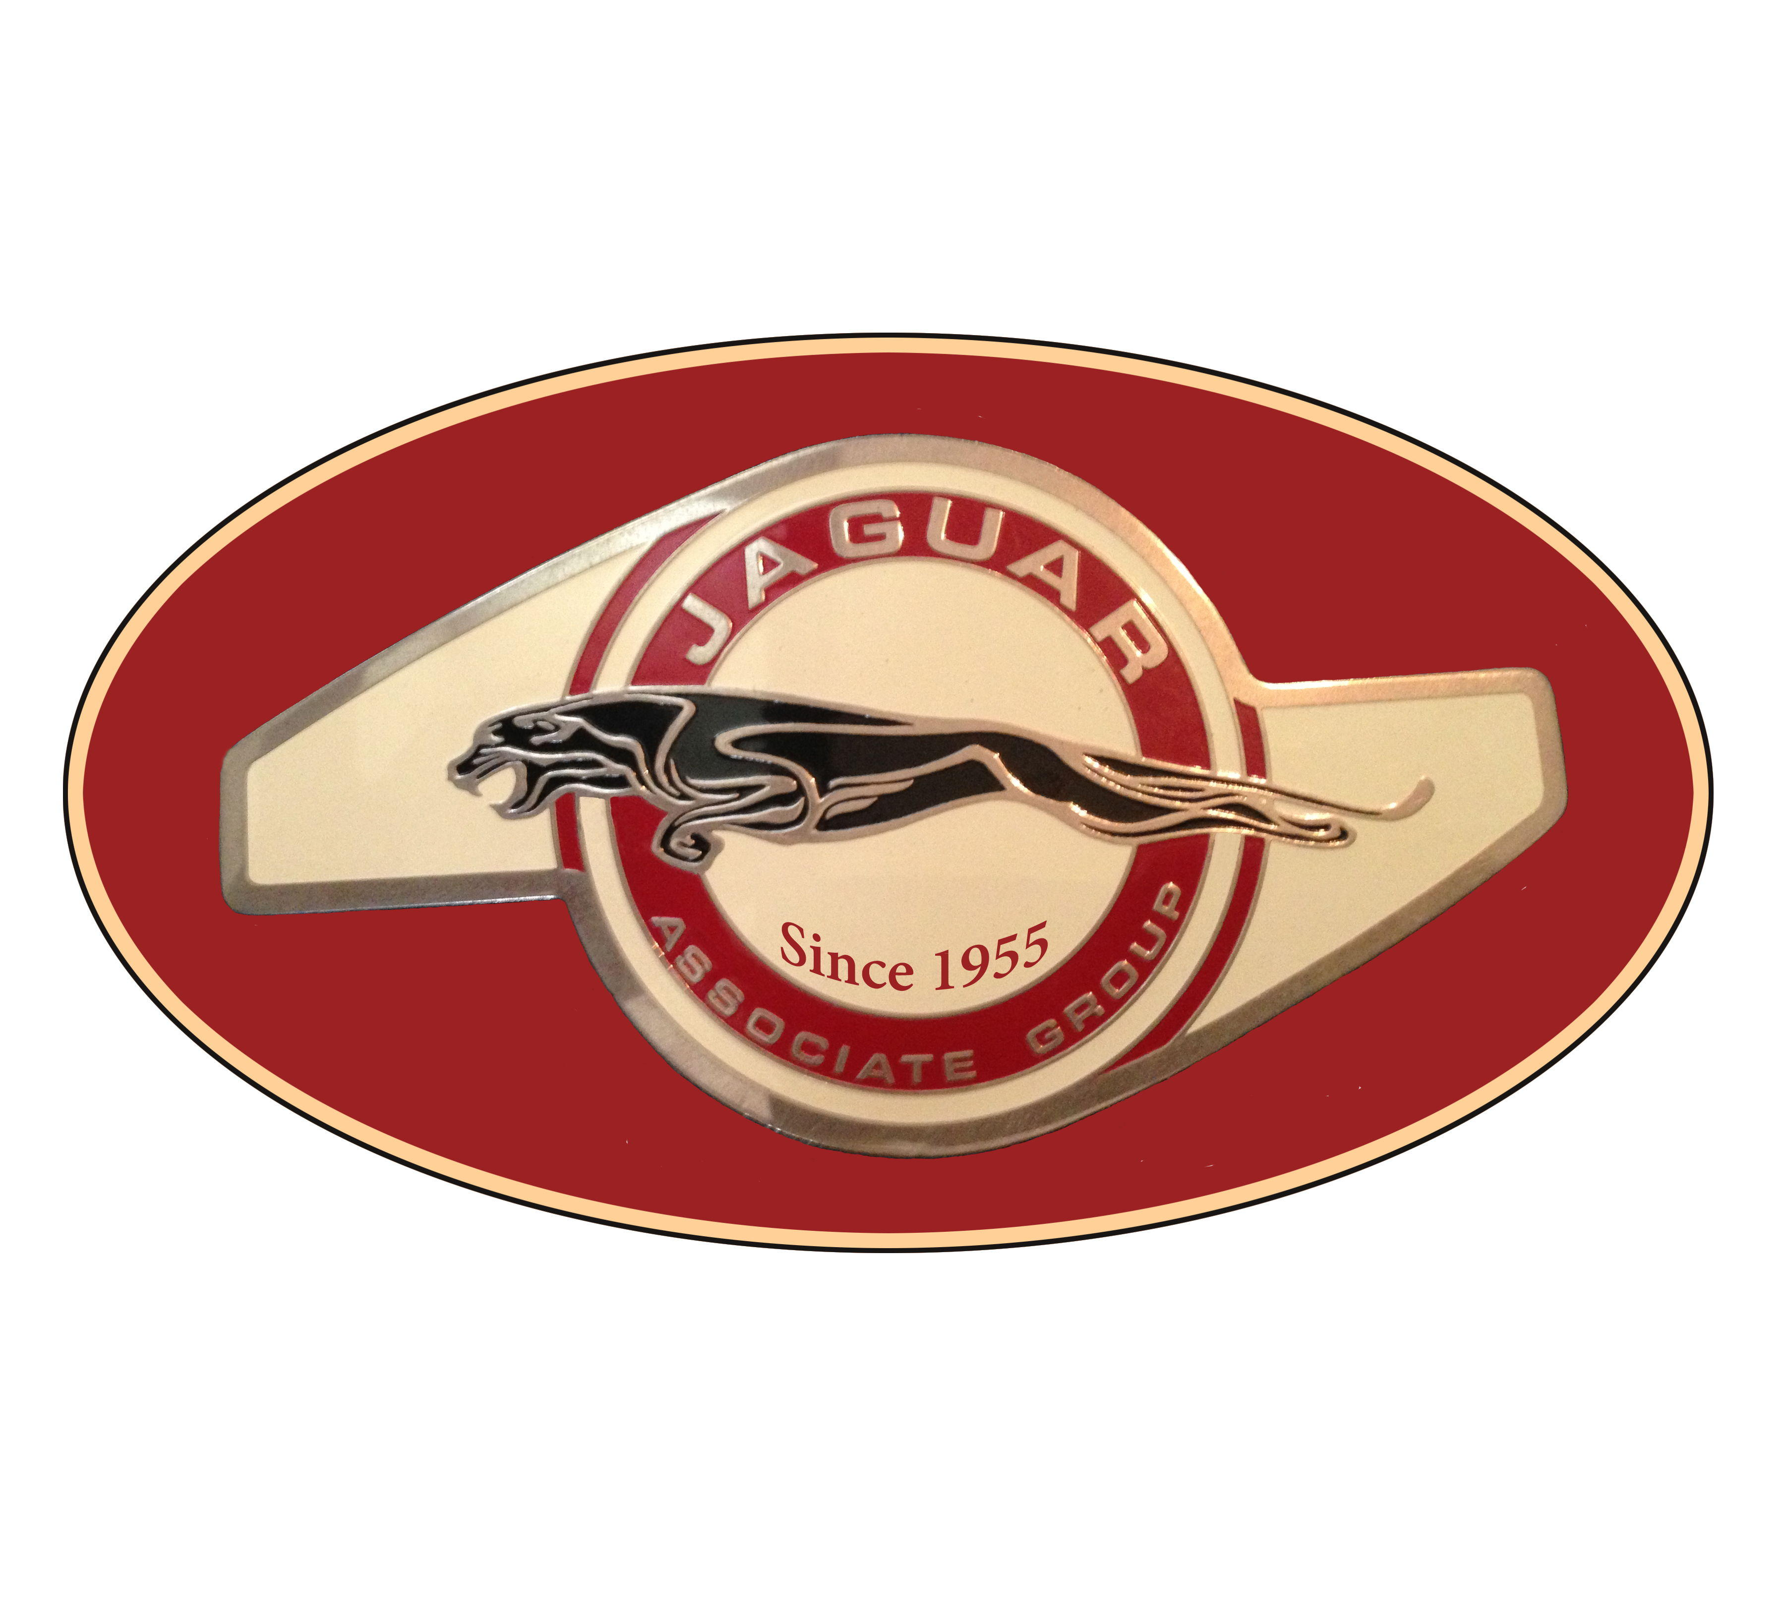 | Jaguars by the Bay  Sat. March 11, 2023  Embassy Suites Hotel  150 Anza Blvd, Burlingame  A People’s Choice Car Show  Overlooking San Francisco Bay | 

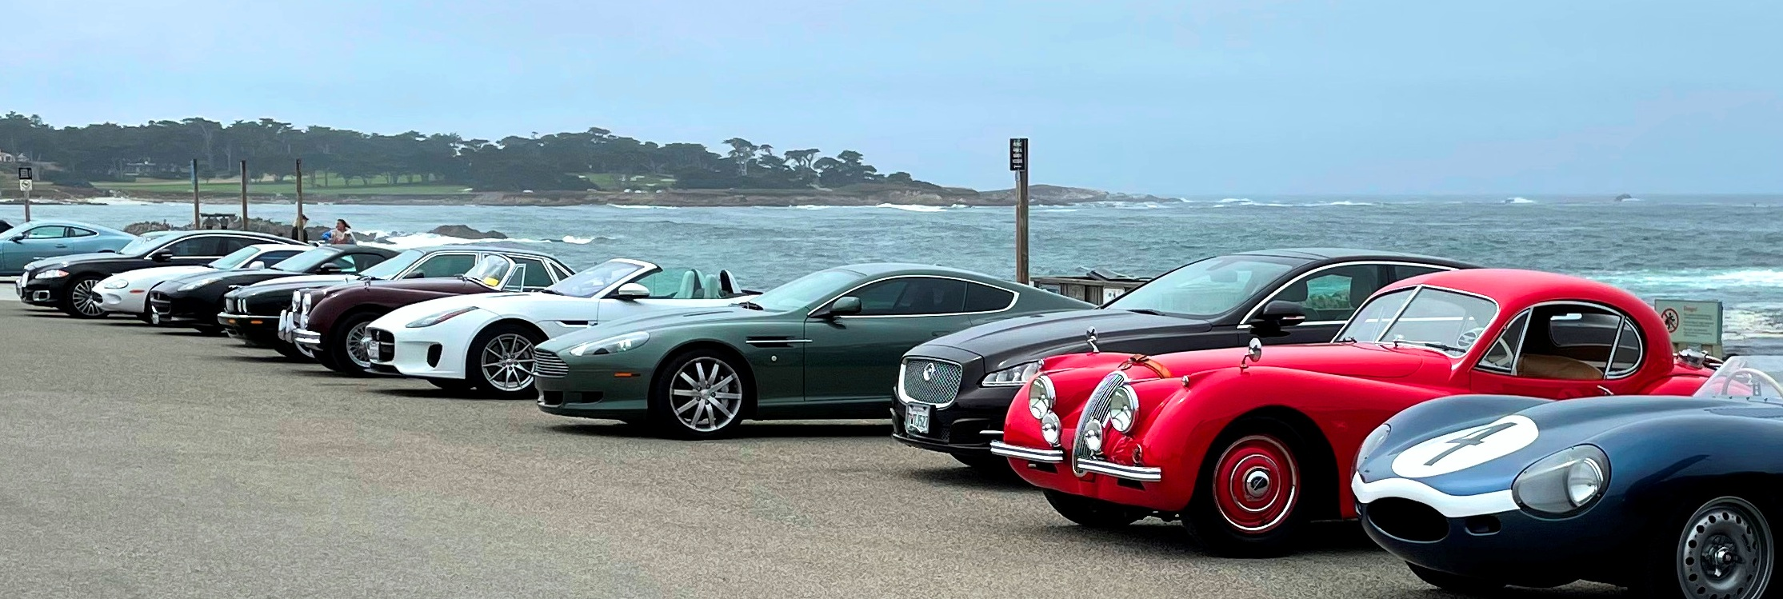
Photo Kristan Neubecker
This is a People’s Choice car show at the Embassy Suites Hotel, in conjunction with the JCNA Annual General Meeting 2023 and open to all Jaguars models from Early Classics to Modern Cars; from Daily Drivers to Full Restorations. This is a fun no stress car show with judging by you the attendees. Awards will be presented in several different classes depending on the number of entries and will be presented at the Awards Banquet in the evening.

Entry starts at 11:00 am. People’s Choice Judging from 1:00 - 4:00 pm.
Cost: $20.
Pre-Registration deadline is Mar 1; register at www.jags.org

---------------------------------------------------------------------------------------------------------------------------------------------------------

Mail in Registration: Fill out the form below with a check for $20, made out to JAG and mail to JAG Treasurer, 37 Campbell Lane, Menlo Park, CA 94025 or payment via Zelle or Paypal to Treasurer@jags.org. To use credit card call 650 854 4445.
Name: _____________________________ Model: __________________________________
Address: ___________________________ __________________________________
City: _______________________________ Year: ______________
State: ___________ Zip code: __________ Color: __________________________________
Email Address: ______________________
Phone: _____________________________
Mobile: _____________________________
Signature: _____________________________________ Date: _____________________________

