Jaguar Clubs Of North America, Inc.  Fred Horner Sportsmanship Award Criteria |  | 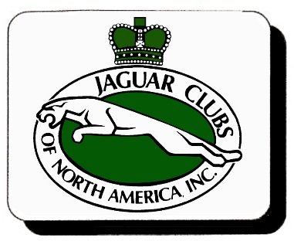
Frederic S. Horner served JCNA as Secretary from 1971 through 1991. For years he handled club memberships and chaired the AGM. We remember him as a diplomat, mentor and friend who helped JCNA became a vital, active organization.. He consistently labored to carry out the original mission of JCNA, to provide a club that could bring Jaguar enthusiasts together in good fellowship and friendly competition. He believed that family enjoyment should be the goal of all JCNA events and his concept of JCNA Championships was based on camaraderie and sportsmanship. The Sportsmanship award honors members who work and compete in JCNA following the ideals and precepts of Fred Horner.
Fred’s oft-stated plan for starting the JCNA Concours Program was to give Clubs and families a nice day out. Competition was secondary to the goal of getting people with Jaguars together in good fellowship. His focus for JCNA was not in competition, but participation. He promoted Concours and other Club events as family outings – a time to relax and enjoy Jaguar cars and fellow members.

The Fred Horner Sportsmanship Award is based upon participation in sanctioned JCNA vehicle events, regardless of how many of each event, the score obtained or the Jaguar entered.
Credit is awarded as follows:
- Concours participation is one credit per Jaguar entered in Championship, Driven, Special and Display Classes, 2 cars per event maximum.
  - Slalom participation is one credit per driver. Class Z does not count for credit.
  - The Driver and Navigator in a Rally both receive one credit.

Participation in all the events of a calendar year would be compiled by JCNA number and the award will be presented to the Member who participated in the most sanctioned events. In the event of a tie, there would be a random drawing to select the Award recipient. Once a Member wins the Fred Horner Sportsmanship Award, he or she will be excluded from receiving the Award again for the next 5 years.

The JCNA website will tally the participation by JCNA membership numbers across all the events and keep a running tally throughout the year. This will encourage additional participation by the Clubs and Members. There is no need to nominate for this award. The compiled participation data is used to select the finalists and winner.

If there are active Junior Members who earn participation credit, their credits will be combined if using the same JCNA family number.

The Fred Horner Sportsmanship Award recognizes JCNA members who are out and about with their Jaguars, sharing fellowship with other JCNA members. It promotes more participation, expands local activities, gets more Jaguars out in front of the public and promotes additional membership.

Get out and enjoy your Jaguars and the fellowship of other Jaguar owners!

