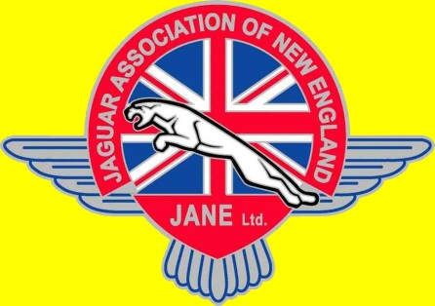
2017 JANE
Spring Slalom
The Jaguar Association of New England (JANE) invites all its members, plus anyone who has an interest in watching or having some real fun, to the Spring Slalom. We all know that nothing can be better than racing your Jag (or any other car) around orange cones on some good asphalt with yummy snacks supplying sustenance!!

Help make it a party on Saturday, June 17, 2017 at the Spring Slalom. Here are the details:

DATE: Saturday, June 17, 2017

TIME: 9 AM – Arrival and set up
10:00-11:30 AM – Registration, Tech and
Novice Driving Coaching & Instruction
11:30 AM-4:00 PM – Slalom
PLACE: 1600 Osgood Street, North Andover, MA (far back parking lot)
(picture below)

RSVP: Paul Bicknell
617-924-6355
pab@mitre.org

Richard Kosinski
978-685-4111
richardkosinski@comcast.net

Glen G.G. McLachlan
508-947-0313
ggmclachlan@verizon.net

FOOD: We plan that there will be coffee/donuts and a sandwich platter for lunch

COST: $30.00 for JCNA members, $35.00 for non-members

Directions to Slalom Location, 1600 Osgood Street, North Andover, MA

Location:
Osgood Landing, adjacent to 1650 Osgood Street (furthest North parking area), North Andover, MA. Enter at the large “Osgood Landing 1600-1650 Osgood Street”.
(GPS users input 1660 Osgood Street and you should arrive directly in front of the “1600-1650 Osgood Street” sign.

Getting there:

From the North, South, or West:
Take Route 495 to Exit 48 Ward Hill / Bradford - Route 125.
At the second traffic light, go right onto Route 125 South.
Continue on Route 125 South for 1.5 miles. 1600 Osgood Street will be on your right.

From the East:
Route 114 West take a Right onto Route 125 towards North Andover follow route 125 North for approximately 4 miles. 1600 Osgood Street will be on your left.

Proceed all the way through the parking lots on the right.

